Re: (Insert Property Address)

Date: (Insert Date)

Dear, (Insert Tenant Name)

Thank you for contacting us regarding your situation and your concerns over your ability to continue to service the rent, this is an un-presendented crisis that no one could see coming to this extent.

We would like to assist you as best we can in this situation to ease the strain, the below information and process is how we, the government and owner can help.
Wendell Property:

Unfortunately, we have an obligation to continue to collect rent on behalf of the landlord. However, we will be as understanding and supportive as we can of you in this situation, and we have already negotiated leniency from your landlord until you are able to gain financial support from WINZ or other government agencies for hardship.

Secondly we would like to assure you that we will not be issuing any additional penalties, costs or rent increases over this time until the effects fo COVID-19 are behind us. Should the rental market soften, and what you are paying now is above the market rate we will work with you and the landlord to adjust as soon as possible. This is all an un-knowen at this point.

New Zealand Government:
The NZ government has released a multi million dollar package aimed at supporting individuals and contractors effected financial by COVID-19. Please see the information below: We recomend you follow the link, and read though this and other sites carefully so you can be sure that you are not missing out on help where you can get it.
https://workandincome.govt.nz/eligibility/emergencies/2020/coronavirus.html#null

The following is snits from the above website around entitlements and support from the NZ Goverment.
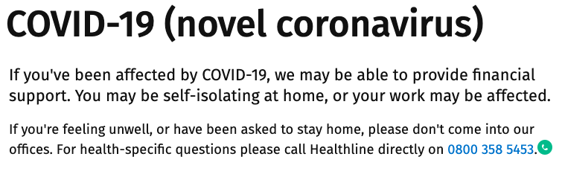
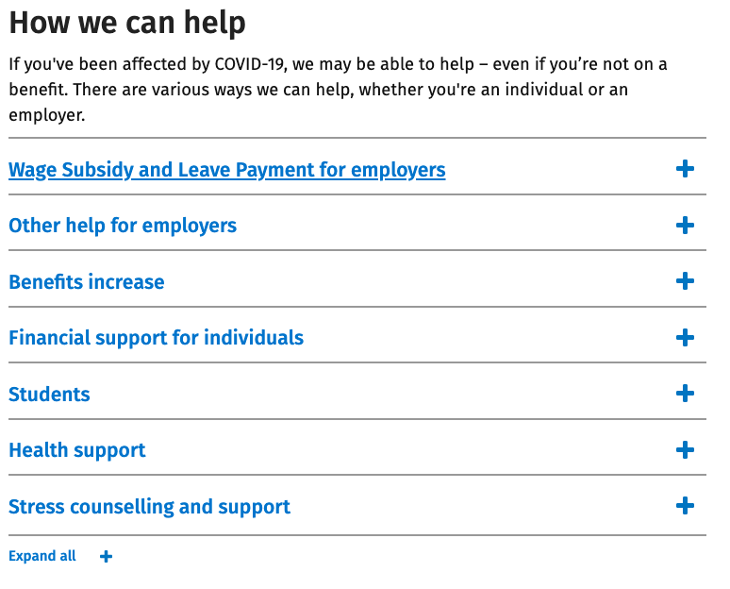
While there are no traditional stand-downs on the above support, the information we have got from tenants who are seeking these payments is that the system is flooded, and it can take a few weeks to get money into your account.
During this down time, legally we have to follow due process, however rest assured we do not want to enforce any more stress on your family. Please understand that these processes are done to comply with the contractual obligations of Wendell Property, and to ensure we are following the RTA and its amendments.

Rental Arrears Process:

Day one of rent arrears: - Text message reminder

Day two: - Email follow up to check that there are no issues with payments leaving your bank.

Day three: - 14 day notice of breach

(this effectively gives you 2 weeks to remedy the lack of rent payment, however we do encourage you to act as quickly as possible as once the 14 days is breached, the landlord is entitled to ask for termination which could be granted, not something we would like to do to you and your family at this time)

Day four or five: - If no payment plan or remedy of the rent has been agreed, it is our obligation to lodge the case for mediation or tribunal. Please note, at Wendell Property this is a last resort for us and we would rather work with you to negotiate leancy until payments take effect, or a payment plan that you are able to stick to to stay ontop of rent, and cover the arrears.

What happens if even after the support, you need to leave the property?

This is a difficult time for landlords, and for tenants alike. At Wendell’s we would like to work with you on your own individual case to keep you in the property and minimise the disruption as best we can for you and your family.

However, should you no longer be able to stay in the property you would need to follow the appropriate notices as based on your lease terms:
For periodic tenancies, you can give 21 days notice to vacate the property.

For fixed term tenancies, you have to undergo a lease break and either
A: Find someone to assign the tenancy obligations to
B: Be let out of your lease legally by the tenancy tribunal based on Section 66 of the RTA (link found here)
C: Be let out by mutual agreement by the landlord.

Thank you for being pro-active, and again we are sorry to hear you are in this situation and our thoughts are with you and your family.
Kia-Kaha and stay safe.

Kind regards,

Wendell Team.

