What is it:

The coronavirus family includes the common cold as well as viruses that cause more serious illnesses, such as the SARS outbreak and Middle Eastern respiratory syndrome, or MERS.

Is it worse than a cold or flu?

Yes, 10 times. According to the latest Australian Influenza Surveillance Report for the 2019 flu season, there were 812 influenza-associated deaths up until October 6. This made up 0.27 percent of the 298,120 laboratory-confirmed notifications of influenza reported to Australian authorities.

This compares to the coronavirus, with the latest numbers suggesting 106 people (2.3 percent) have died out of 4515 known cases.
Prof McBride said it appeared coronavirus was more severe than influenza, although it may not be worse than severe acute respiratory syndrome (SARS), which originated in China and killed nearly 800 people globally in 2002 and 2003.

Symptoms:
The symptoms of most coronaviruses are similar to any other upper respiratory infection, including runny nose, coughing, sore throat, and sometimes a fever. In most cases, you won't know whether you have a coronavirus or a different cold-causing virus, such as rhinovirus.
You could get lab tests, including nose and throat cultures and blood work, to find out whether your cold was caused by a coronavirus, but there's no reason to. The test results wouldn't change how you treat your symptoms, which typically go away in a few days.
But if a coronavirus infection spreads to the lower respiratory tract (your windpipe and your lungs), it can cause pneumonia, especially in older people, people with heart disease, or people with weakened immune systems.

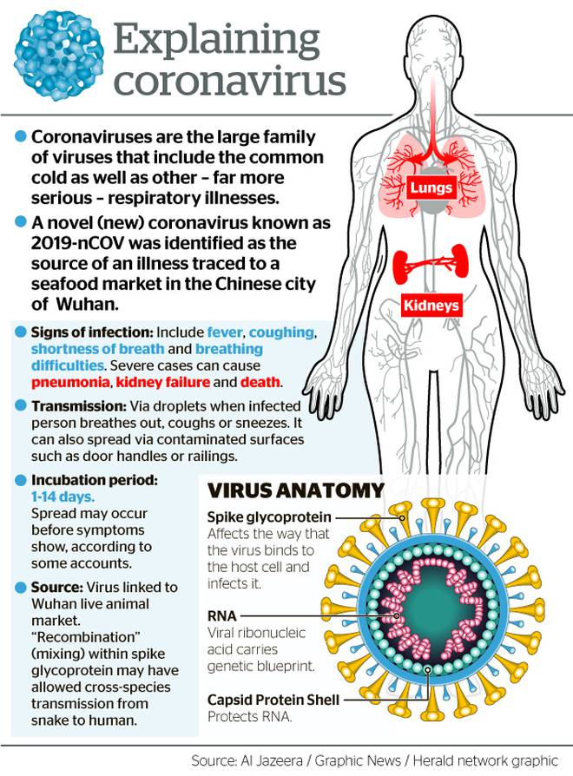

Prevention and treatment of the new coronavirus
There is currently no vaccine to prevent infection. The best way to do so is to avoid exposure to this virus. The CDC recommends the following everyday preventive actions to help prevent the spread of respiratory viruses:
- Wash your hands often with soap and water for at least 20 seconds. If soap and water are not available, use an alcohol-based hand sanitizer.
- Avoid touching your eyes, nose, and mouth with unwashed hands.
- Avoid close contact with people who are sick.
- Stay home when you are sick.
- Cover your cough or sneeze with a tissue, then throw the tissue in the trash.
- Clean and disinfect frequently touched objects and surfaces.
Treatment
There is no specific antiviral treatment recommended for 2019-nCoV infection. People who are infected should receive supportive care to help relieve symptoms. For severe cases, treatment should include care to support vital organ functions.
People who think they may have been exposed to the virus should contact their health care provider immediately.

Suggested best practice steps for Property Managers:

- Follow all avoision techniques mentioned above.
- Notify your tenants prior to a viewing that you will be attending, and if anyone has traveled to china or suffered symptoms of Coronavirus to notify the office immediately and the inspection will be rescheduled until a clean bill of health from the tenants is supplied. (Template examples below)
- Inform your owners of the health precautions you are undertaking, and that this may affect their routine inspection times, but they will be notified of this case by case.
- Purchase hand sanitizer, respiratory masks and other protective gear for your team as required.
- Hold training with the team to discuss the changes, and ensure that they are aware of the risks, and ways to avoid the virus spreading. (You may use this as an example in training)
- Follow up with your team in writing with everything they need to know about keeping themselves safe.
- If the team is at risk (via travel or symptoms) don’t have them in the office, have them seek medical advice immediately, and monitor those they have been in contact within the previous 2 weeks.

Suggested text for Inspection Templates:

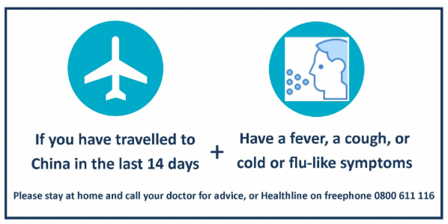

“With the recent outbreak and subsequent spreading of the Coronavirus, ________________ Property Management are asking if you or anyone in your home or who has visited your home have traveled to infected areas, and or had symptoms of the virus.
If anyone in the home has recently traveled to Whan, China or any other infected areas please notify the office immediately prior to the inspection. We will happily re-schedule as the health and well being of our team is paramount.

If you are feeling any symptoms that you may feel could be related, contact a health professional immediately. You can call the Health line on 0800 611 166 free of charge at any time. Thank you”

Suggested text for tenants attending viewings:

“With the recent outbreak and subsequent spreading of the Coronavirus, ________________ Property Management are asking if you or anyone in your home has traveled to infected areas, and or had symptoms of the virus.
If or anyone you have been in contact with has traveled to Wuhan, China or any other infected areas please notify the office immediately prior to viewing the property. We will happily re-schedule as the health and well being of our team, and tenants in the home are paramount.

If you are feeling any symptoms that you may feel could be related, contact a health professional immediately. You can call the Health line on 0800 611 166 free of charge at any time. Thank you”

